**PF LAB #3 TASK**

**Name :** Muhammad Jawwad

**Section & Roll No. :** BCS 1K-0536

Task 4:

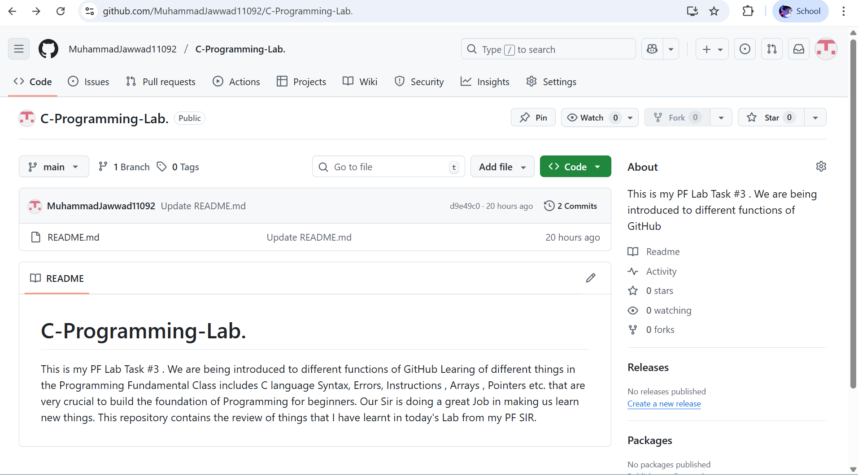

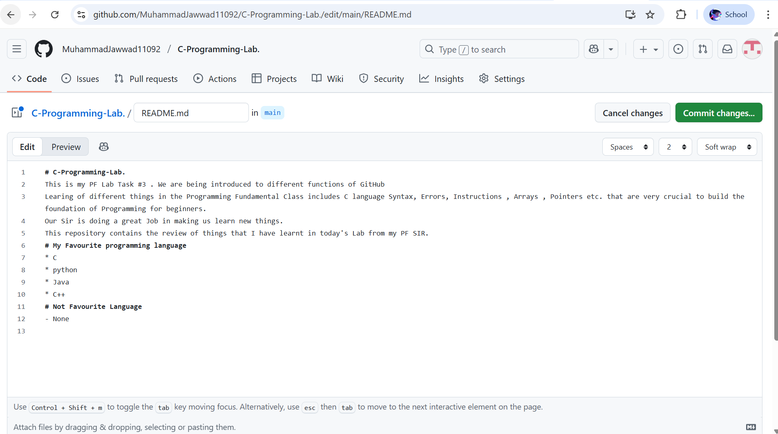

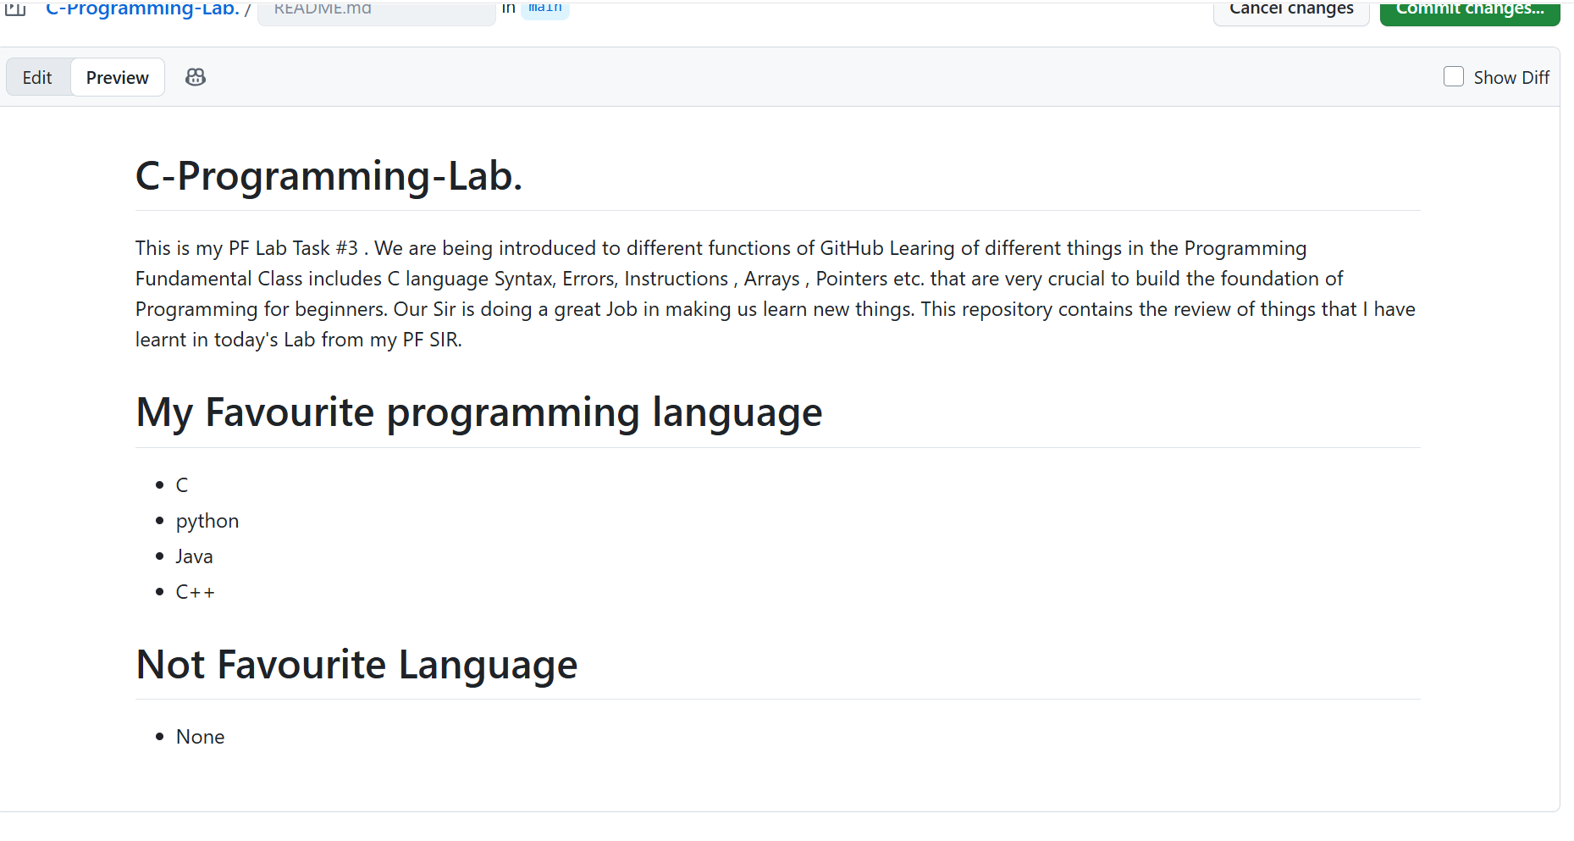

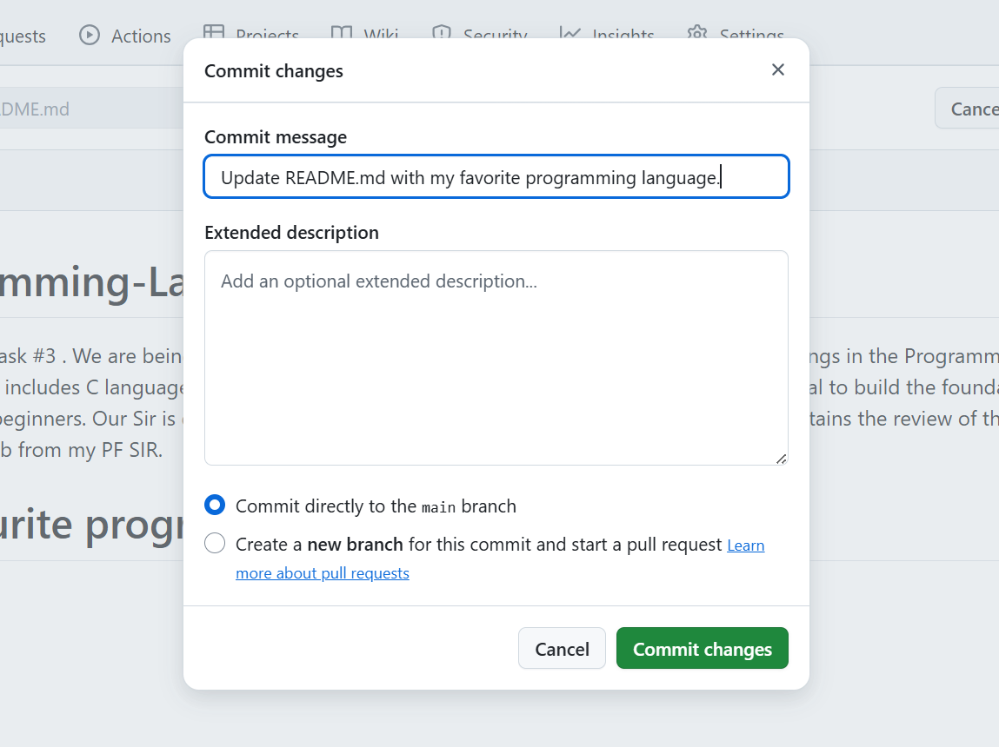

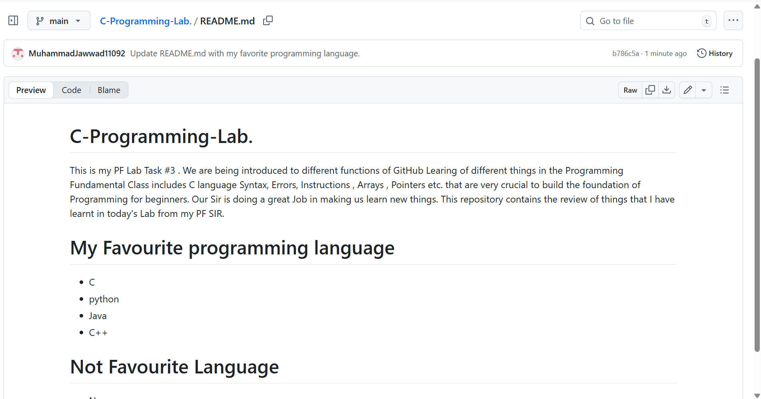

https://github.com/MuhammadJawwad11092/C-Programming-Lab./blob/main/README.md

Task 5:

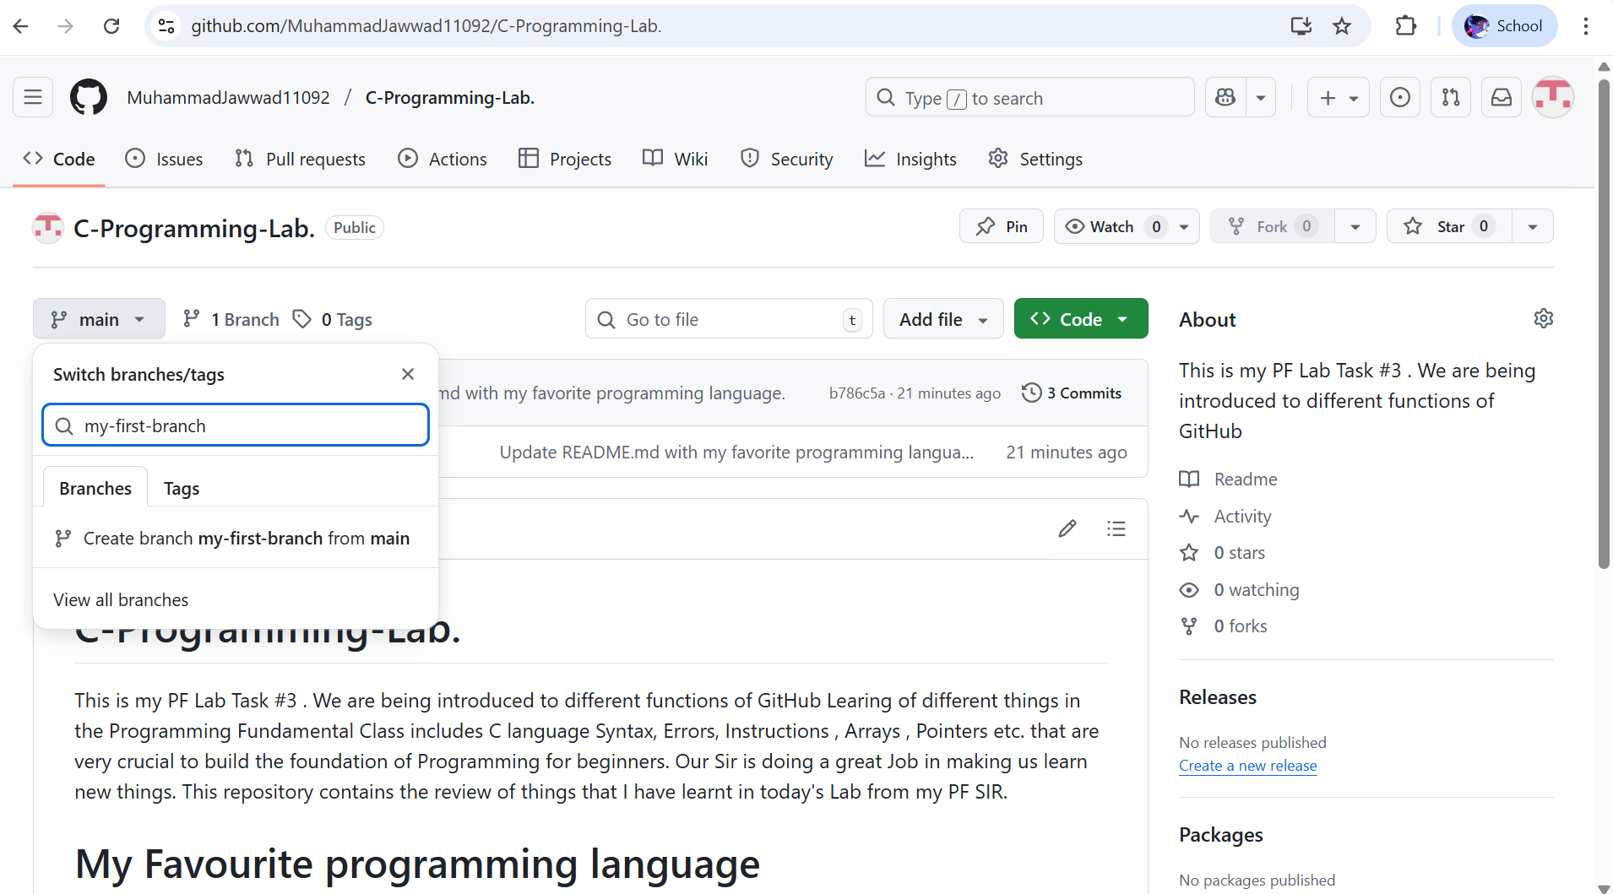

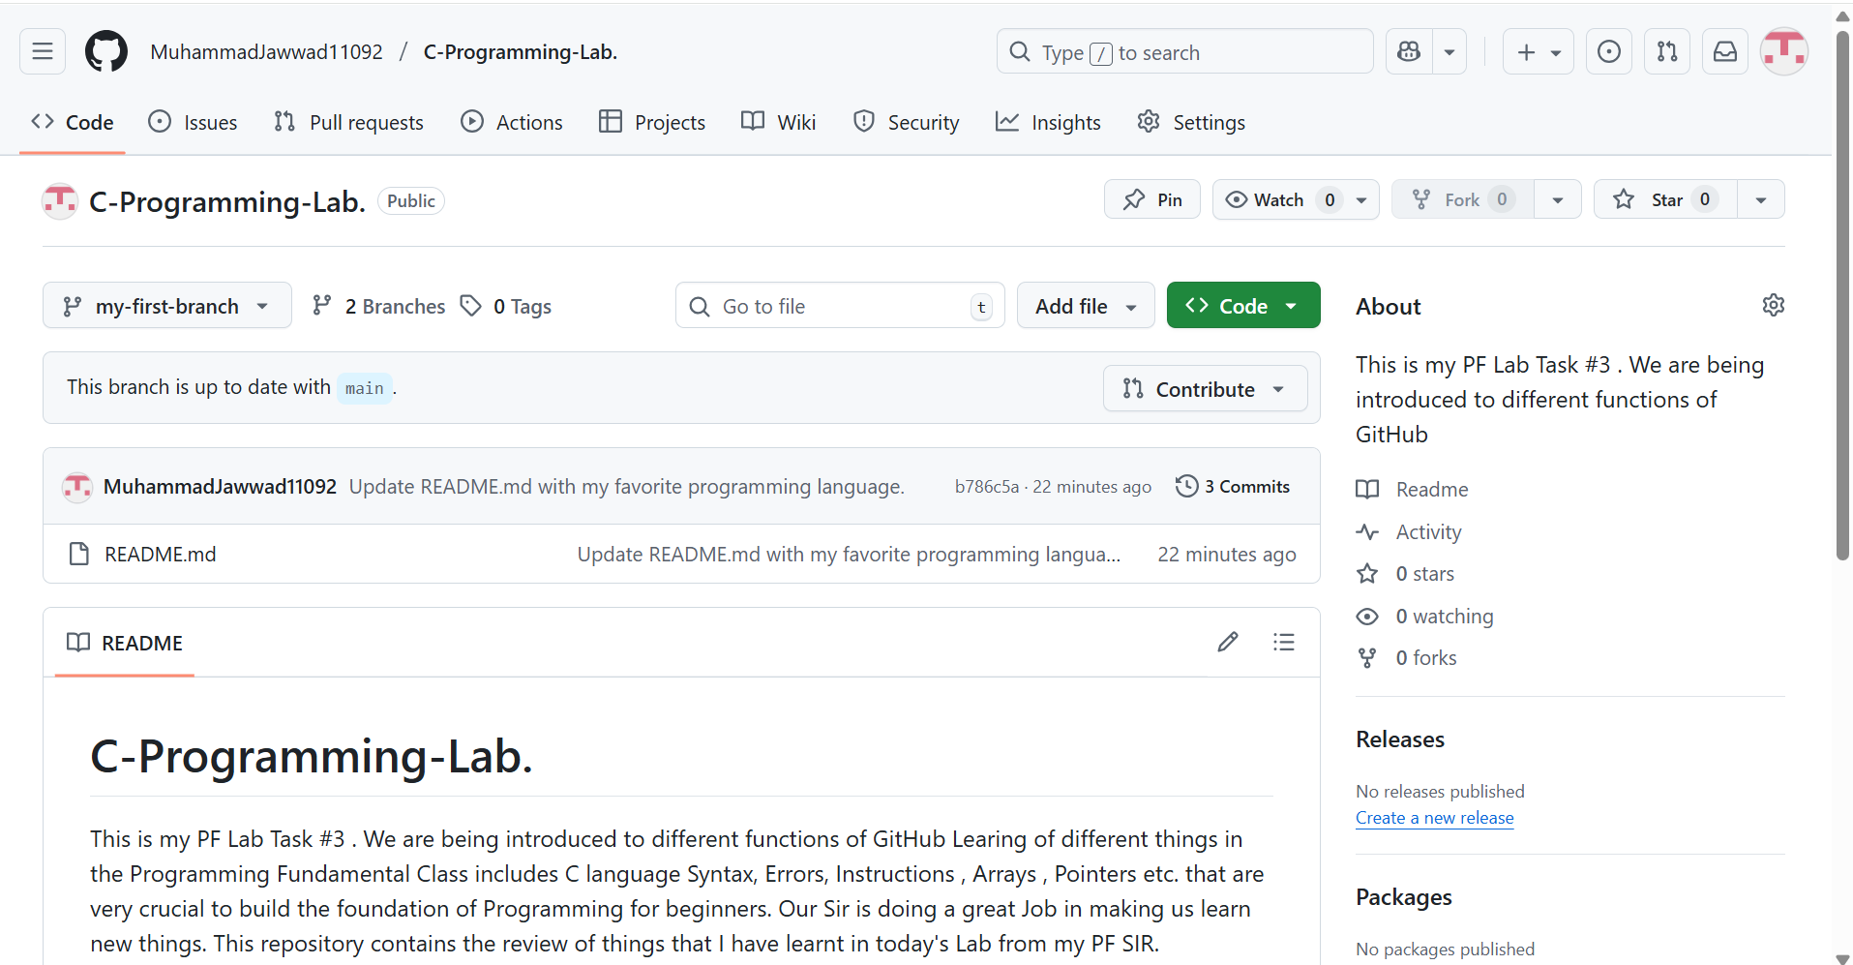

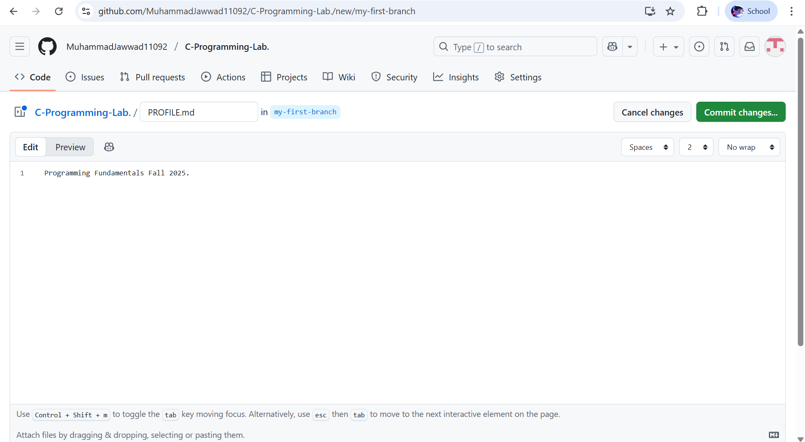

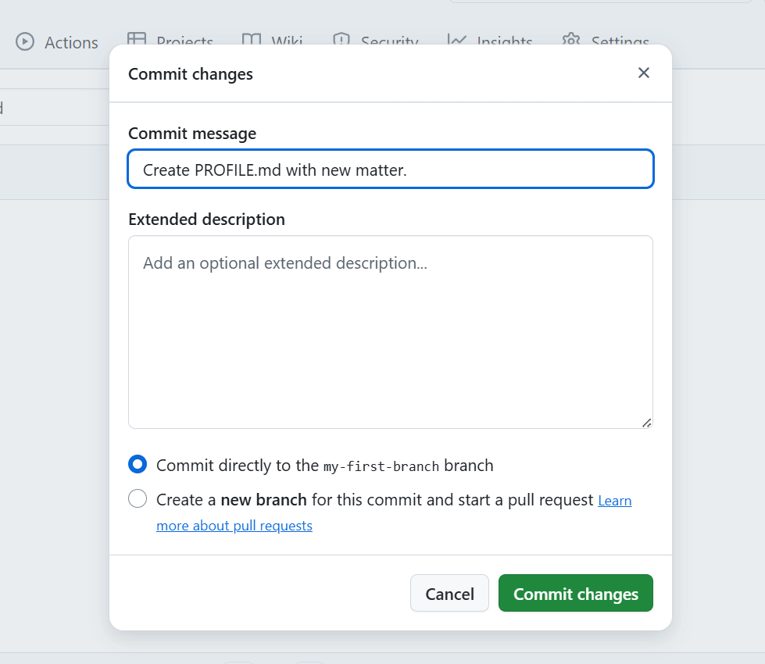

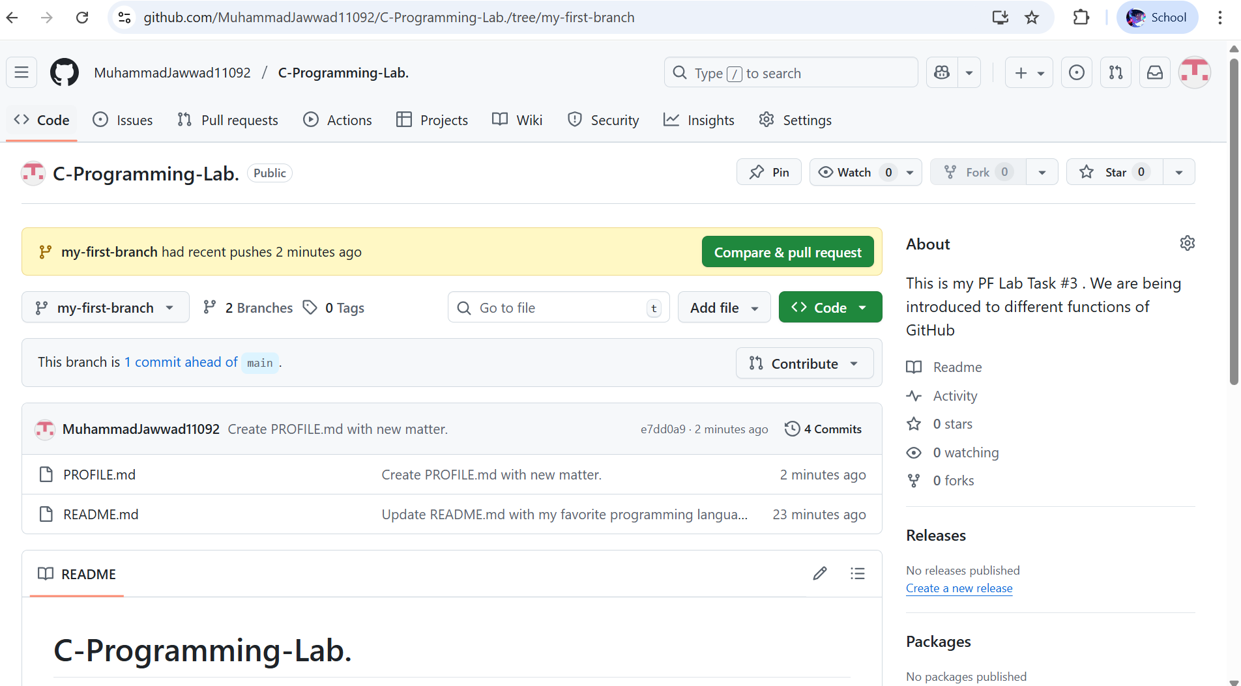

https://github.com/MuhammadJawwad11092/C-Programming-Lab./tree/my-first-branch

Task 6:

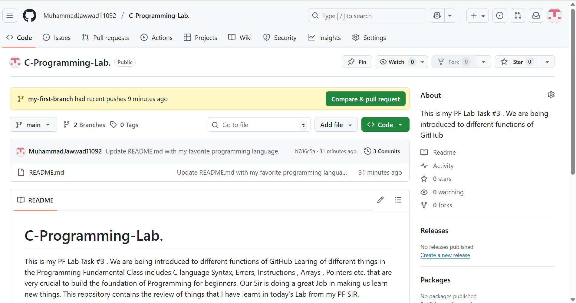

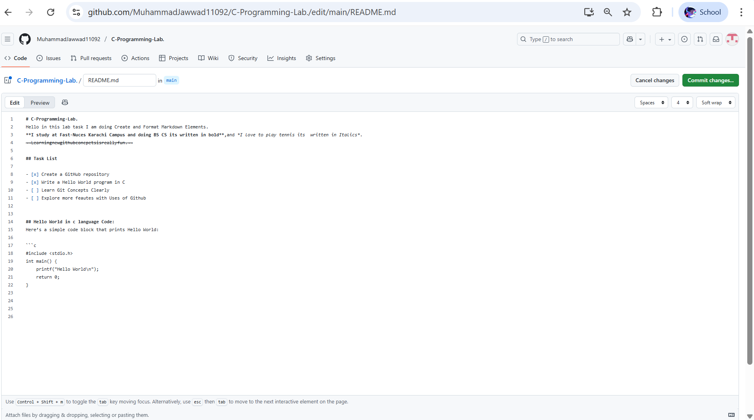

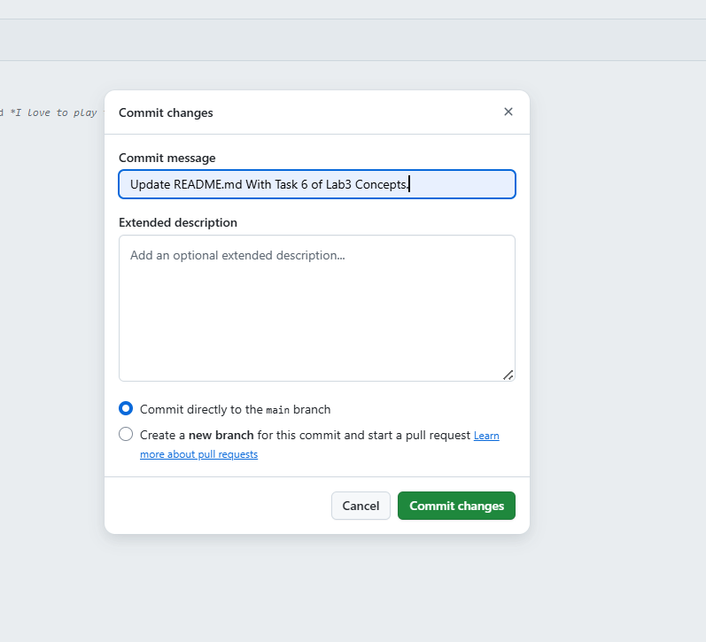

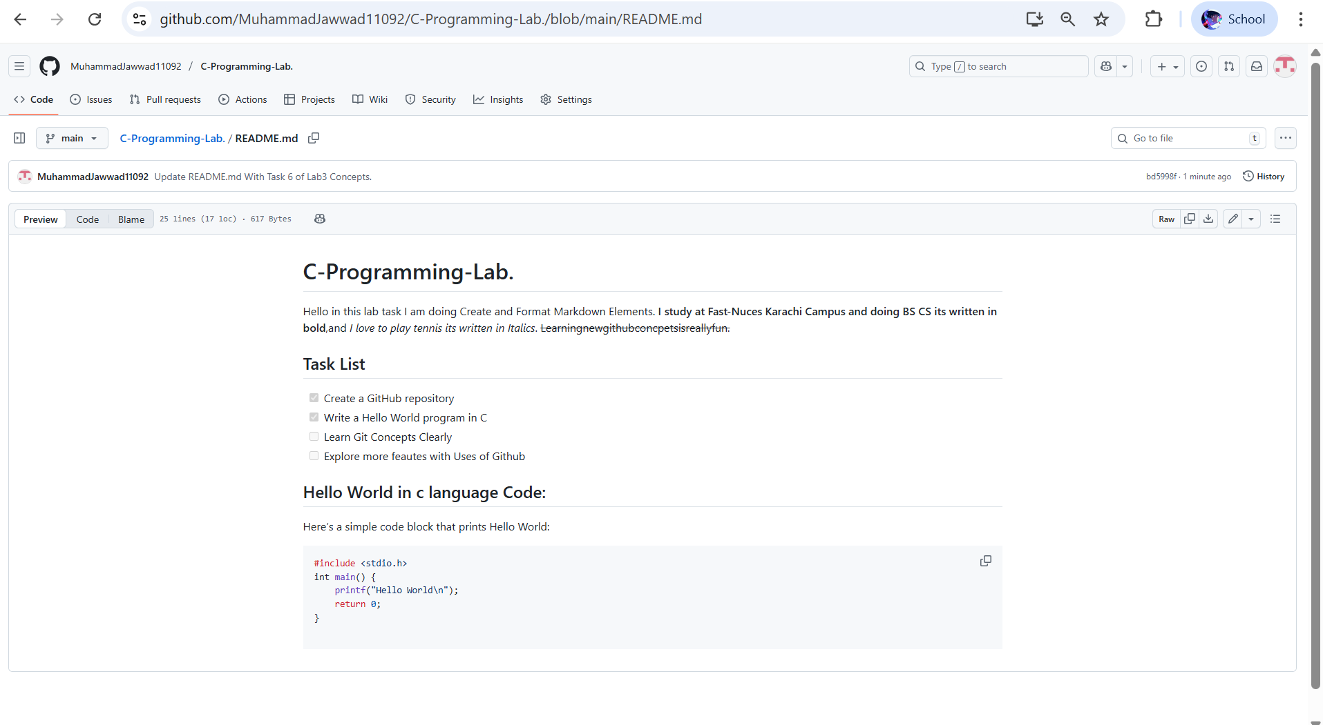

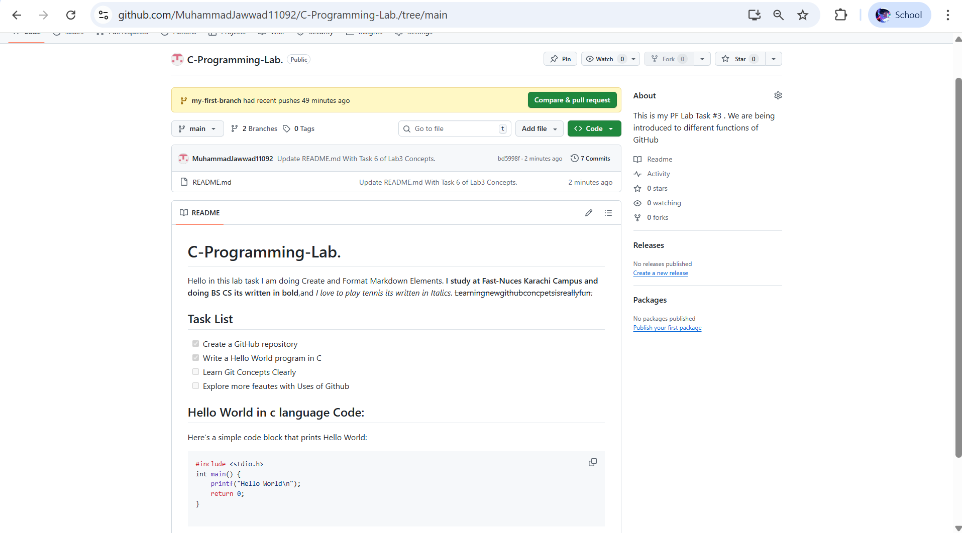

https://github.com/MuhammadJawwad11092/C-Programming-Lab./blob/main/README.md

Task 7:

Code:

#include <stdio.h>

int main()

{

int age;

float height;

printf("Enter Your Age\n");

scanf("%d", &age);

printf("Enter Your Height in meters\n");

scanf("%f", &height);

printf("\n--- User Details ---\n");

printf("Your Age is : %d \n ", age );

printf("Your Height is : %.2f meters \n", height);

return 0;

}

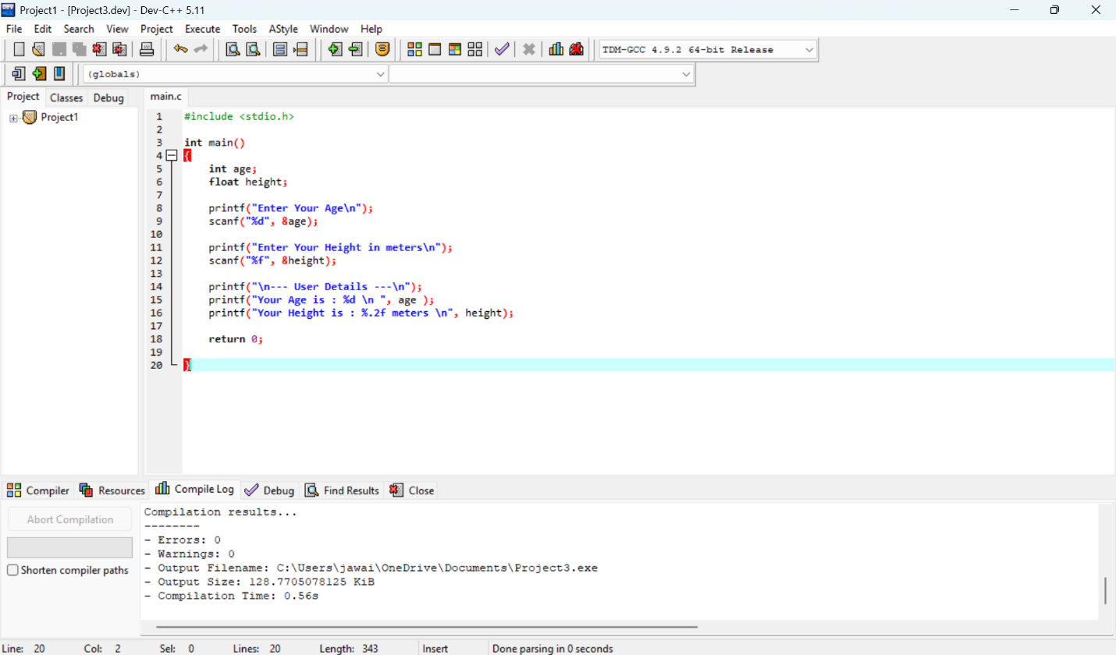

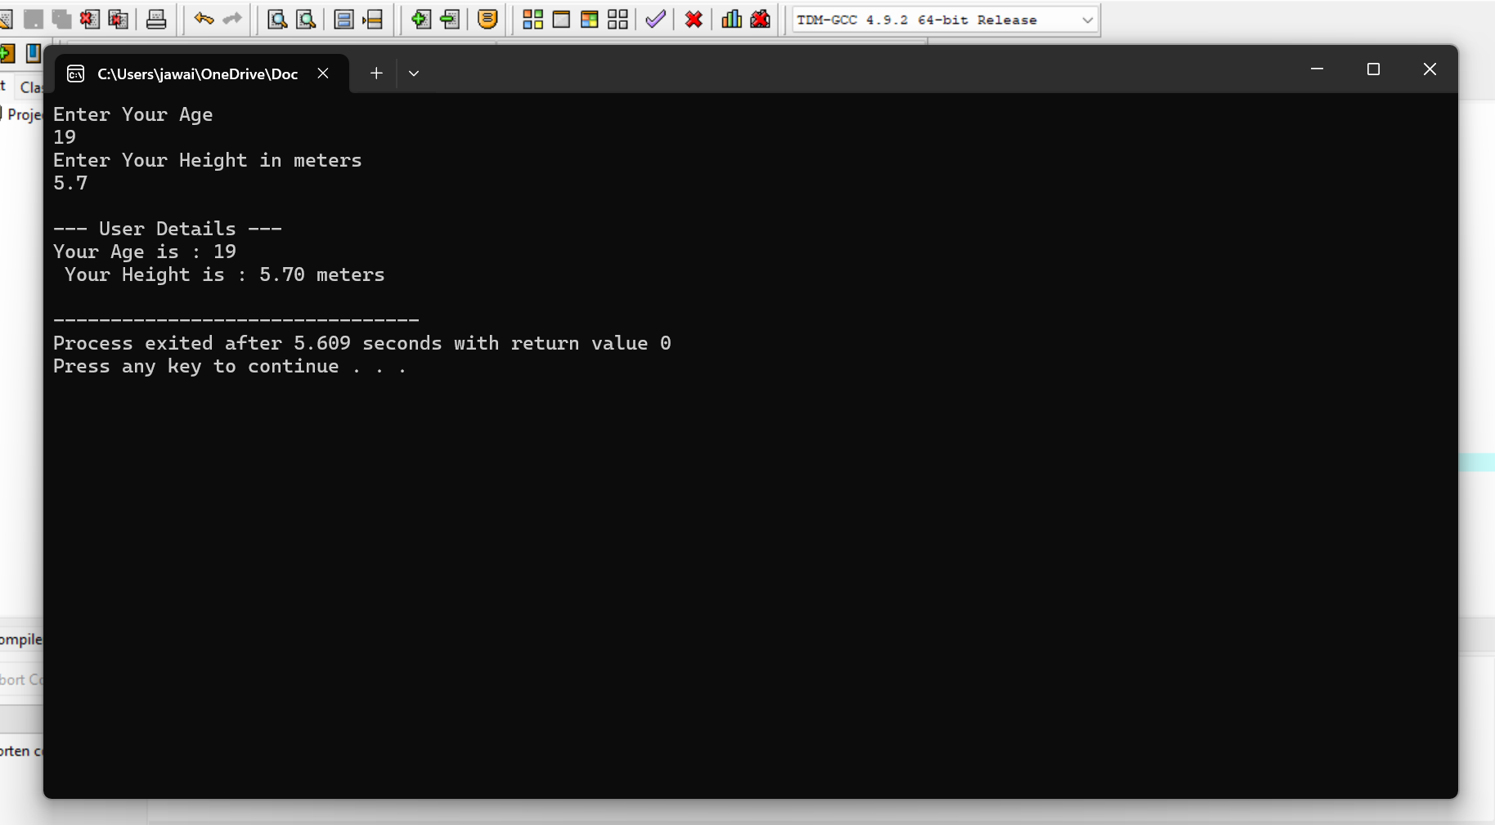

Task 8:

Code :

#include <stdio.h>

int main()

{

printf("Escape Sequences Showing:\n"); // \n newline

printf("1.\tThis line shows a tab space.\n"); // \t ? tab

printf("2. Here we print a double quote for showing: \"Hello World \"\n"); // \" double quote

printf("3. This is how a backslash works and looks: \\\n"); // \\ backslash

printf("4. Multiple lines\ncan be printed\nusing newlines symbol.\n"); // multiple \n

return 0;

}

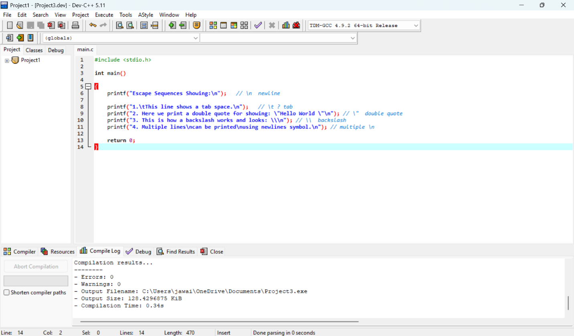

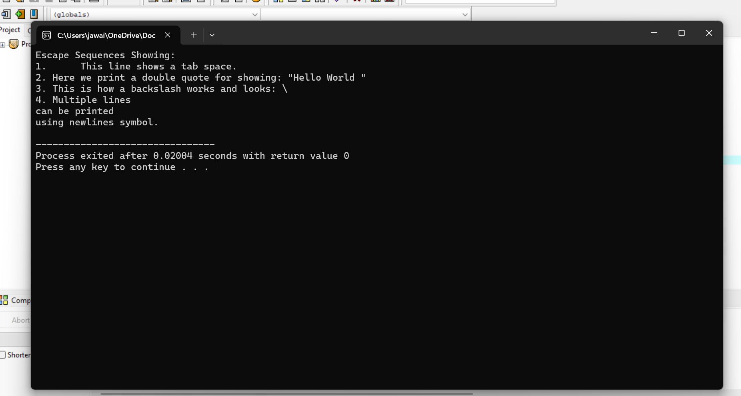

Task 9:

Code :

#include <stdio.h>

int main()

{

int Birth_Year;

int Current_Year;

printf("Enter Your Birth Year\n");

scanf("%d", &Birth_Year );

printf("Enter The Current Year\n");

scanf("%d", &Current_Year );

printf("Your Current Age : %d\n", Current_Year-Birth_Year);

return 0;

}

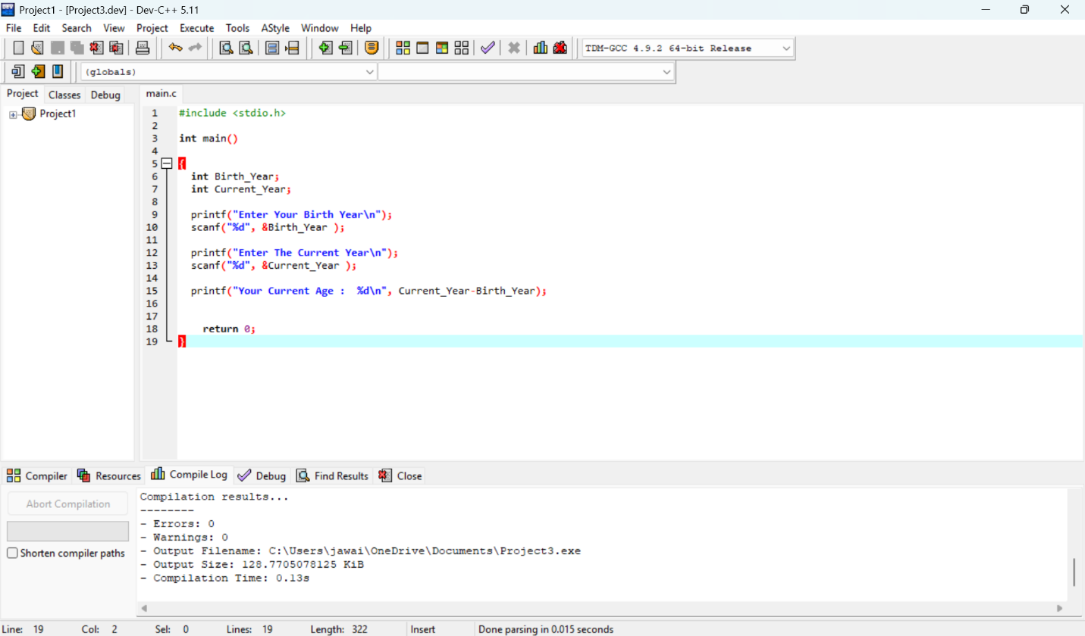

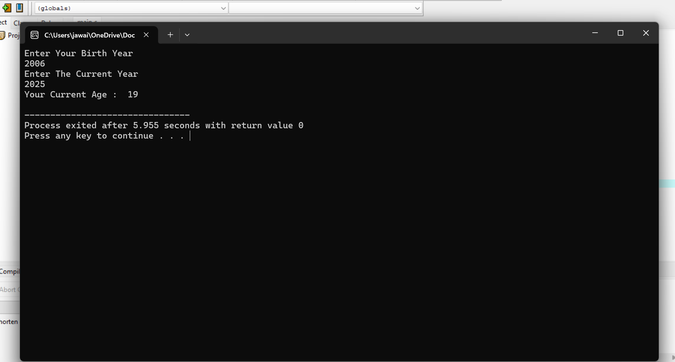

Task 10:

Code :

#include <stdio.h>

int main()

{

int years, months, days;

//input of age

printf("Enter your age in years: ");

scanf("%d", &years);

//calculation

months = years * 12;

days = years * 365; // (ignoring leap years)

// Output of Program

printf("\n--- Age Converter ---\n");

printf("Age in Years : %d\n", years);

printf("Age in Months: %d\n", months);

printf("Age in Days : %d\n", days);

return 0;

}

